András L. Komáromi

# **A proposal for the usage of UML and OntoUML diagrams to represent philosophical concepts**

01.01.2021

# **Summary**

**In the last 30 years, information technology produced tens of thousands of information systems covering and infiltrating into almost all the aspects of human endeavor, from business processes to linguistics, from military to life sciences and driverless cars. To have effective and precise communication among the different people (system analysts, architects, designers, programmers, testers, etc.) working in the IT industry, the necessity of a standardized language capable of representing cognitive models of such a variety of the different areas of reality emerged.**

**After different trials, in 1997,** [**UML**](http://www.uml.org/what-is-uml.htm)(Unified Modeling Language), a widely known general-purpose modeling language used in software engineering, developed and maintained by [OMG](https://www.omg.org/) (Object Management Group) to respond to this demand, was standardized. UML is a useful tool for capturing and representing abstract entities' essence and their relations, processes, and behavior of different systems.

For conceptual modeling focusing on the areas where the ontology is critical [**OntoUML**](https://ontouml.org/), an ontology-driven conceptual modeling language, practically an extension of UML was proposed in 2005 by Giancarlo Guizzardi and his colleagues working in Ontology & Conceptual Modeling Research Group ([NEMO](https://nemo.inf.ufes.br/en/)). OntoUML is based on the theoretical foundation worked out in the Unified Foundational Ontology (UFO).

**Because UML and OntoUML have the capability to represent abstract conceptual structures in a highly standardized and formalized manner - in my opinion - they have the intrinsic capacity to be used in such surprising areas as philosophy.**

**The scope of this paper is to demonstrate the feasibility of the graphical representation of philosophical concepts using UML** **and OntoUML diagrams and methods.** I think that this approach could help in philosophy for mapping, explaining, clarifying and model checking, in the same way as symbols in mathematics.

I divided the paper into two parts:

* a short, simplified, and incomplete introduction to the OntoUML and UML diagram types suitable for usage in philosophy
* a few UML and OntoUML diagrams are presenting ideas taken from Ibn Sina's (Avicenna) work.

Other of these kinds of diagrams you can find on my blog: [www.philosophy-models.blog](http://www.philosophy-models.blog).

# **UML and OntoUML diagram types usable in philosophy**

This section will present some basic concepts of the OntoUML and UML languages necessary to understand the models I propose in chapter 3.

For the representation of philosophical concepts and structures I propose the usage of the following diagram types:

* OntoUML *Class (or Type) Diagrams*, which are a kind of UML Class diagrams extended with a special notation.
* UML *Use Case Diagrams*
* UML *Activity Diagrams*

OntoUML defines only the featured diagram type, while UML specifies seven (Class, Collaboration, Internal Structure, Use Case, Interaction, State, Activity, Component, Deployment, State Machine, Sequence, Communication, Package)*.*

# **OntoUML diagrams**

# ***Representation of OntoUML classes (Types) and relations, multiplicity***

OntoUML Class (or Type) diagrams provide a static view of the entities and their relations which persist in time (endurants). The diagram is built upon the distinction between Classes and Individuals, or in the term used in philosophy Universals and Particulars. The relation that holds between a Class and an Individual is called instantiation, e.g.:

* Class (or Type): Human
* Instance: Socrates, Alexander the Great, Richard Wagner, [Eliud Kipchoge](https://www.runnersworld.com/news/a23244541/berlin-marathon-world-record/)

In OntoUML we represent **Types** or **Classes** as boxes. Every Type must have a name and a **Stereotype**, can have attributes and operations:

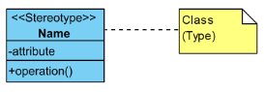

**Figure 1.** *Representation of a Class in OntoUML*

Different line types enhanced with stereotypes represent different types **of relations** between classes. 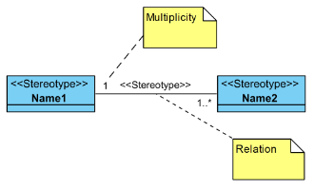

**Figure 2:** *Representation of a relation and multiplicity in OntoUML*

The values at the end of the relation lines indicate the **multiplicity of the relations**.   
**Multiplicity** defines a **cardinality** (**number of elements**) - of a collection and is an inclusive interval of non-negative integers. Usual values are:

* 0..1: zero, or one
* 1: exactly one
* 0..*: zero or more
* 1..*: one or more
* n: exactly n
* *: any number

Form the example below we can “read” the following:

* One Human has exactly one ActualAge
* One Human has one or more MentalSkills

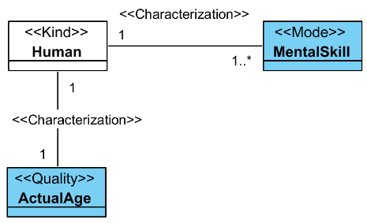

**Figure 3:** *Example of simple OntoUML diagram*

# ***OntoUML class stereotpes, examples***

Based on the Unified Foundational Ontology (UFO) [1], the categorization of the Class stereotypes defined for **Endurant Universals** is according to the taxonomy explained below, in figure 2 and table 1:

* Endurants can be split into **Substantials**(e.g. humans, books, cars), which are existentially independent, and **Moments**, which depend existentially on Endurants (e.g. citizenships, marriages, colors, wights of different objects).
* **Intrinsic Moments** depend existentially in one single individual (e.g, a person’s weight, a professor’s mood).
* **Substantials**can be split into Sortal Universals and Mixin Universals.
* **Sortal Universals** provide uniform *identity principle* for their instances, which supports the judgment whether two individuals are the same or not. The identity principle also informs which changes an individual can undergo without changing its identity.
* The instances of a **Rigid Sortal**class cannot cease to be members of the given class without ceasing to exist. In other words, rigid types are the ones who define essential characteristics to their instances. E.g. Usain Bolt cannot “leave” the rigid class of Humans without ceasing to exist.
* **A Substance sortals** provides*“directly”* identity principle to its instances.
* **Anti-rigid Sortals**, characterizes classes whose instances can move in and out of its extension without loosing their existence. E.g. Eliud Kipchoge existed before being an instance of the ProfessionalAthlete class, and will exist after finishing racing.
* **Mixins** *(or Non-Sortals)*aggregate properties from different Sortals, classify things that share common properties but which obey different principles of identity. They do not provide a uniform principle of identity for their instances. E.g. the class ArtPiece aggregates the properties of PieceOfMusic, LiteraryWork, Performance, Painting, Sculpture etc.   
  The principle of *rigidity* and *anti-rigidity* can also be applied to distinguish different types of Mixins.

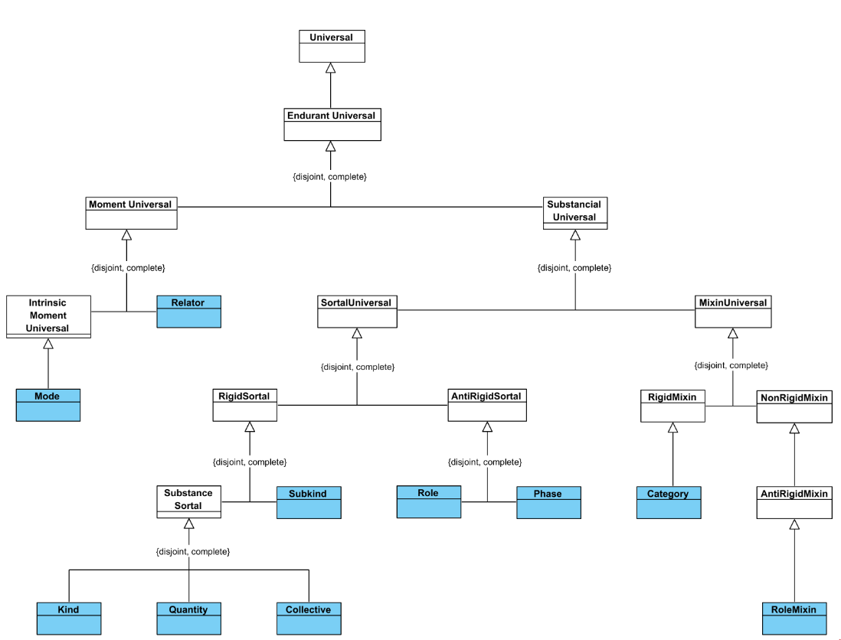

**Figure 4.** *Taxonomy of OntoUML stereotypes according to [1]*

**Table 1:** examples of OntoUML elements, class and relation stereotypes used in Chapter 3.

|  |  |
| --- | --- |
| **Example** | **Explanation** |
|  | Classes: Human, Woman, Man   * «Kind» stereotype (Human) is a *Substance sortal* used to represent classes that provide directly rigid identity principles to their instances, and do not require a *relational dependency.* Classes with Kind stereotype are present in almost all OntoUML diagrams. * A «Subkind» stereotype (Woman, Man) represents a *Substance sortals* used for specializations of *identity providers* (like <<Kind>>). It does not provide identity principle directly, but inherits from the parent class. E.g. the Woman and Man is subkind of the Human.   Relations/Constraints:   * The constraint represented with an arow-head line is *Generalization.* Whenever a new instance of a Class is always included in an other class also, we say that the former is a subtype of the latter. To represent this constraint in OntoUML models, we use the generalization. E.g.: if we add Augustine of Hippo to the Class of Man, that is added to the class of Humans also.   Reading: Woman and Man are subkinds of Human kind. |
|  | Classes: PhysicalBody, Matter   * «Kind» (PhysicalBody) * The «Quantity» stereotype (Matter) is a *Substance sortal* representing uncountable things, like Water, Clay, or Beer. It represents a maximally topologically connected amount of matter.   Relations/Constraints:   * “«Containment» is a relation between a <<Quantity>>, which is a content, and a container.   Reading: The kind of PhysicalBody contains Matter. |
|  | Classes: Human, Teacher, Teacher’sUnion   * «Kind» (Human) * «Role» (Teacher) * <<Collective>> stereotype (Teacher’Union) represents a *Substance sortal* which is a collection of parts with homogenous internal structure, where all parts are considered equal.   Relations/Constraints:   * ***Part-whole relationship, with shared part***, **(represented with black diamond)** where the part can be included in *more than* one composite (whole) at a time. «MemberOf» is a parthood relation between a <<Collective>> and its parts.   Reading: Teacher is a role of Human, is a member of the Teacher’sUnion collective. |
|  | Classes: Human, Philosopher, Engineer   * «Kind» (Human) * A «Role» stereotype (Philosopher, Engineer) represents an *anti-rigid sortal* used for specializations of identity providers («Kind», «Collective», «Quantity», «Relator», «Mode» and «Quantity») that are instantiated based on a relational property. In our case we have a relational property towards Work.   Relations/Constraints:   * The constraint represented with an arow-head line is *generalization.*   Reading: Philosopher and Engineer are roles of Human. |
|  | Classes: Human, Child, Adolescent, Adult   * «Kind» (Human) * A «Phase» stereotype (Child, Adolescent, Adult) represents an *anti-rigid sortal* used for subtypes of identity providers, “that are instantiated by changes in intrinsic properties (e.g. the age of a person, the color of an object, the condition of a car). All instances of a particular «Phase» must follow the same identity principle. Phases always come in partitions” [2]. E.g. Child, Adolescent and Adult are phases of Human.   Relations/Constraints:   * The constraint represented with an arow-head line is *generalization.*   Reading: Child, Adolescent and Adult are phases of Human. |
|  | Classes: Work, Teaching, Research, CreatingPodcast   * «Kind» (Teaching, Research, CreatingPodcast) * A «Category» stereotype (Work) *is a rigid mixin* which aggregates essential properties to individuals following different rigid identity principles. Categories are abstract, can not be instantiated.   Relations/Constraints:   * The constraint represented with an arow-head line is *generalization.*   Reading: The kinds Teaching, Research, CreatingPodcast belong to Work category. |
|  | Classes: PracticeTeacher, Teacher, Student, Human   * «Kind» (Human) * «Role» (Teacher, Student) * The «RoleMixin» stereotype (PracticeTeacher) represents an *anti-rigid mixin* which captures common characteristics of roles sssigned to entities of different Kinds.   Relations/Constraints:   * The constraint represented with an arow-head line is *generalization.*   Reading: Teacher and Student are roles of Human. PracticeTeacher is a role mixin of Teacher and Student. |
|  | Classes: Human, Teacher, Knowledge   * «Kind» (Human) * «Role» (Teacher) * «Mode» stereotype (Knowledge) represents an *Intrinsic moment universal,* which isparticular type of intrinsic property without a structured value. Modes existentially depend on their bearers. * Relations/Constraints: * “«Characterization» is a relation between a bearer type and its feature, like a <<Mode>>” [2]   Reading: Teacher is a role of Human. Knowledge is a mode, which characterizes Teacher. |
|  | Classes: WorkContact, Human, Teacher, University   * «Kind» (Teacher, University) * «Relator» stereotype (WorkContract) is a *Moment universal* which is used represent truth-makers of material relations, i.e., the "things" that must exist in order for two or more individuals to be connected by material relations. E.g. The teacher has to have a WorkContract to work for a University.   Relations/Constraints:   * We define a relation of «Mediation» between a «Relator» and the entities it connects. A «Relator» mediates at least two distinct individuals. * «Material» relations have material structure on their own. E.g employments, enrolments, works performed etc. «Material» relation can be completely derived (via «Derivation») from the «Relator» and the corresponding «Mediation» relations.   Reading: Teacher is a tole of Human. Teacher works for university, which is in material relation. WorkContract relates Teacher with University. |
|  | Classes: Human, Organ   * «Kind» (Human, Organ)   Relations/Constraints:   * ***Part-whole relationship, with exclusive part* (represented with black diamond)**, where the part could be included in at most one composite (whole) at a time.  Here the Organ is exclusive part of the Human. «ComponentOf » is a parthood relation between two complexes.   Reading: Organ is exclusive part of Human. |

# **UML use case diagrams**

**UML defined Use case diagrams** are static *behavior diagrams* used to describe a set of actions *(use cases)* that some system performs in collaboration with one or more ***external users*** of the system (**actors**).

The main elements of a use case diagrams are:

* *System:* an information system, usually but I used to represent a soul or a mind
* *Actor:* an external user of the system
* *Use case:* a specification, description of the behaviour of an entity on its interaction with outside agents, performed in order to achieve a goal.
* *Association relation:* is a relation representing a communication between the between actor instance and use case instance.
* <<Include>> relationship: A use case can incorporate the behaviour of an other use case, as a part of its own behaviour. The *Including use case* depends on the *included use case*, which is required and not optional, so the including use case is **not functional** by itself. Use cases csan be included by more *including use cases*.
* <<Extend>> relationship: When a base *(extended) use case* is supplemented (optionally) with the behaviour of an other, *extending use case* we have an <<Extend>> relationship. The Extended use case is meaningful on its own, it is independent of the extending use case. Extending use case typically defines optional [behavior](https://www.uml-diagrams.org/common-behaviors.html#behavior) that is not necessarily meaningful by itself.

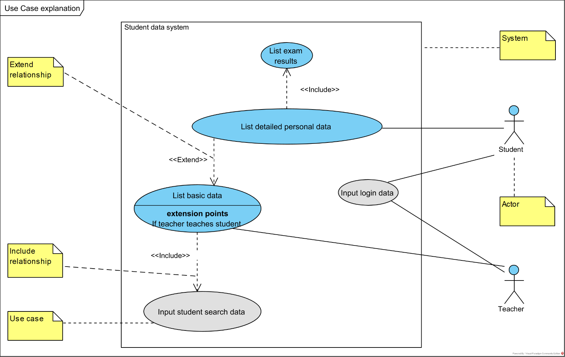

**Figure 5.** *Example of UML use case diagram*

The use case diagram above features:

* *System:* Student data system
* *Actors:* Teacher, Student
* *Use cases:* “List basic data”; “Input login data”; "Input student search data"; "List detailed personal data"; "List exam results"
* <<Include>> and <<Extend>> relationships
* Actor-use case communication

Reading:

From the point of view of the Teacher:

* The Teacher interacts with “Input login data” by typing login and password
* The Teacher can “List basic data” e.g. name of student, birthdate, faculty. This includes also possibility to “Input student searh data.
* In cases where the Teacher teaches the student, the “List basic data” is extended with “List detailed personal data”(e.g. social status, contact data), which includes the “List exam results” also.

From the point of view of the Student:

* The Student interacts with “Input login data” by typing login and password
* The Student gets its own “List detailed personal data”, which includes the “List exam results” also.

# **UML activity diagrams**

**Activity diagram** is dynamic UML [behavior graph diagram](https://www.uml-diagrams.org/uml-25-diagrams.html#behavior-diagram) which shows *flow of control* with *nodes* (activities, actions, controls) and *edges* (control flows) with emphasis on the sequence and conditions of the flow. It is used to represent flows within then IT system, but also wokflow, where humans and IT systems are also included. The actions coordinated by activity models can be initiated when other actions finish executing, because objects and data become available, or because some events external to the flow occur.

* *Action* (node) represents a single atomic step, which changes the state of the system and that is not further decomposed
* *Activity* (node)is abstract element, which groups, includes actions, control flows and control nodes
* *Control flow* (edge)is a relationship which governs and sequences the flow of control between two nodes.
* *Initial node, final node* (control node)
* *Synchronization bar* (control node)
* *Decision node* (control node)
* *Swimlane:* showsthe executor of the included nodes

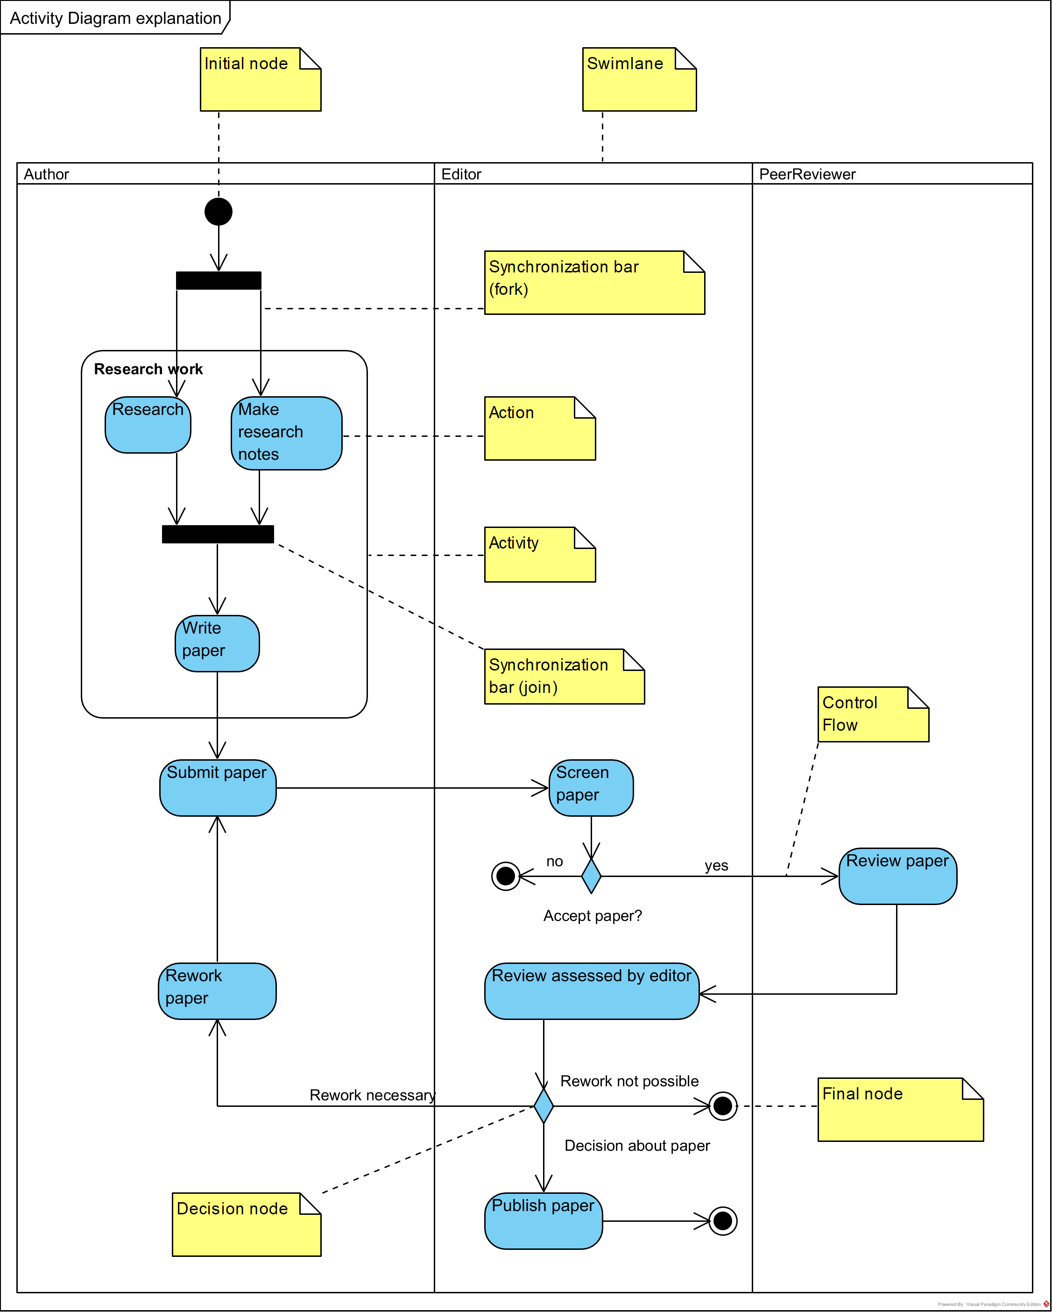

**Figure 6.** *Example of UML activity diagram*

The activity diagram above features:

* *Actions:* “Research”; “Make research notes”; “Write paper”; “Submit paper”; “Screen paper”; “Review paper”; “Review assessed by editor”; “Rework paper”; “Publish paper”
* *Activity:* “Research work”
* *Control flows*
* *Initial node, final nodes*
* *Synchronization bars*
* *Decision nodes:* “Accept paper”; “Decision about paper”
* *Swimlanes:* “Author”; “Editor”; “PeerReviewer”

Reading: the activity diagram the workflow of publishing a paper in a journal.

# **Examples of usage of OntoUML and UML diagrams**

In this chapter, I present some examples of usage of the three types of selected diagrams for some widely-known ideas of the great Persian philosopher Ibn Sina (Avicenna, 980-1037 AD).

Each chapter includes a short description of the philosophical model discussed, an OntoUML or UML diagram and an explanation which supports the diagram mostly with excerpts from different sources.

# **Usage of OntoUML (class) diagrams**

# ***Ibn Sina's methaphysics***

Ibn Sina presents his metaphysical framework in the treatise Ilāhiyyāt of Kitāb al-Šifā' (known in English as the Metaphysics of the Book of the Healing or the Book of the Cure), in which:

* *Existence* is separated *being (a thing)*, the latter is named *quiddity* (or essence). We can comprehend the quiddity of a thing without knowing anything about its existence.
* Things can be *material singulars – sensibles,* externals to the human, and *concepts* in the human mind. The corresponding mental and external existence are on the par for Ibn Sina.
* A *thing* is a composition of existence and quiddity.
* The necessary *existent* is it’s own existence, and as such is necessary; all the other things are contingent.

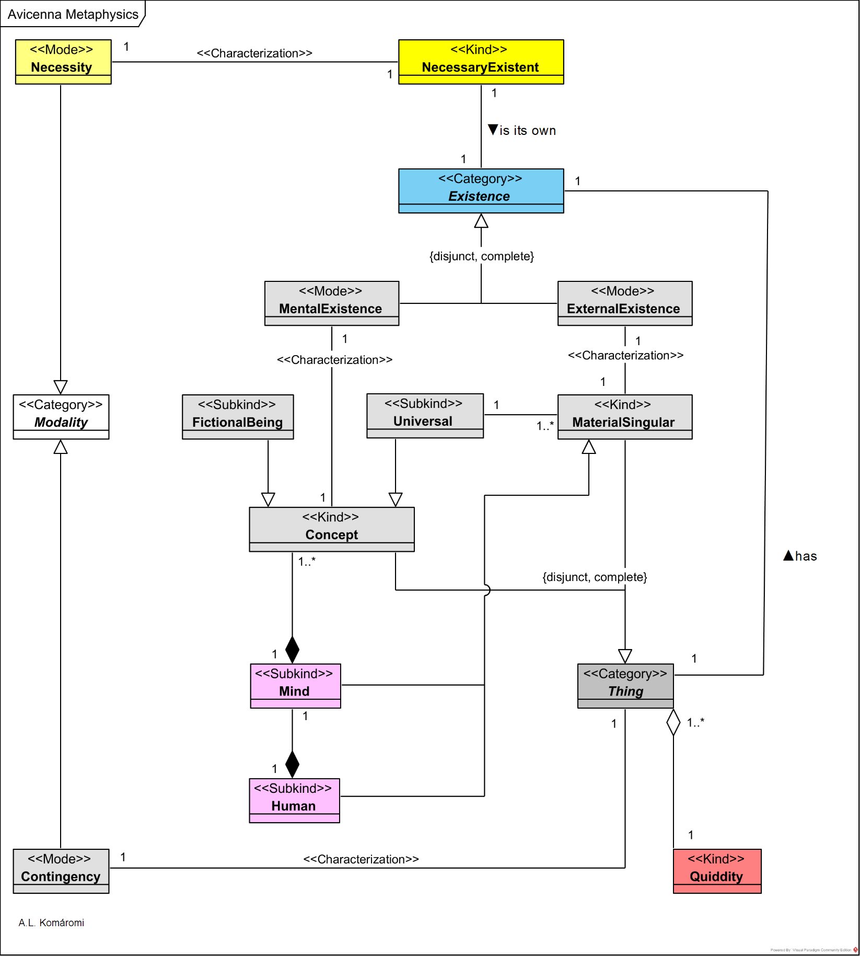

**Figure 7.** *Ibn Sina’s metaphysics presented on OntoUML diagram*

**Table 2:** main concepts in Ibn Sina's methaphysics

|  |  |  |
| --- | --- | --- |
| **Type (Class)** | **Description** | **Relations/Constraints** |
| Necessary Existent | "the **Necessary Existent** has no essence or no quiddity that differs from existence (anniyya) and is therefore beyond essence. The first attribute of the Principle is 'that It is and that It is existent' (inn wa-mawǧūd): existence is not what It 'has': It simply is […] absolutely necessary and simply coincides with, or more exactly, is Its own existence… The Necessary Existent has no cause. It has relations in so far as it is existent. […] the ‘thing’ in question is only necessary existence, it has no quiddity (or no quiddity beyond its existence) and is not, properly speaking, a “thing” (Bertolacci 2012a): in this case, in fact, what is revealed is the existence of the Necessary Principle, which is pure existence on condition of not and can therefore be conceived beyond essence and thingness.” [3] Necessary Existent is also referred as ***First Principle*.** | is its own Existence |
| Existence | **Existence** (al-mawǧūd) can be: mental, external, and the existence of the Necessarry Existent. Existence and being (a thing) are distinct. "Avicenna posits a distinction between the *being* of the thing and its *existence*. Clearly, then, the fundamental and primary character of being does not imply simplicity: to exist means to be a given entity in the world or—as Avicenna also uses it—a *'thing'*. The existence of something must thus be distinguished from its being what it is."[3] |  |
| Mental Existence | "everything that is conceived of or simply mentally represented exists and hence has at least a **mental existence** (which means either intellectual or imaginary or estimative). Indeed, the existent as such is immaterial and only non-existence in the absolute sense does (obviously) not exist, since it cannot be either conceived or discussed" **(**Lizzini, 2019**)** | descendant of Existence; characterizes Concept |
| External Existence | **External existence** (fī l-ʿayān) is existence in concrete material singulars. | descendant of Existence; characterizes MaterialSingular |
| Quiddity | **Quiddity** (māhiyya), essence or thingness is independent of existence, and necessarily accompanies the thing, be it particular or universal.   "the **quiddity** or essence of a thing is not in its turn a thing" with its own mental existence so that, once added to (real) existence, it could become a real thing… What Avicenna states by distinguishing quiddity and existence is that **quiddity** does not coincide with its existence: neither with its mental existence, which is related but does not correspond to universality, nor with its concrete existence (fī l-ʿayān), which implies individuality… The indifference of quiddity to any kind of existence and determination truly establishes the correspondence between reality and knowledge: it is exactly because quiddity is in itself neither real nor mental that it can be present both in reality and in the mind, accompanied by the determinations of either individuality or universality: in concrete reality there is x in its particular existence, while in the mind there is x with its possible multiple predication. In this respect, the consideration of quiddity in itself—which corresponds to the thing in itself as expressed by its definition—transcends both levels of existence (external and mental) and in one passage is equated to the "divine existence" (wuǧūd ilāhī) of something that depends on God's providence." **[3]**  E.g. "horseness" (which is common in the concept of the horse, and in Tucker, the horse). | is shared part of the Thing, Concept and MaterialSingular |
| Thing | "In every **thing** the distinction between what the thing is and the fact that it is is inevitable. Existence can consequently be said to be external to essence, so that ***an existing thing, whose essence or quiddity is possible, can be said to be composed of essence and existence. […]*** In order to ask what a thing is, one cannot avoid referring to being, which is exactly what allows us to conceive all things, whether they are sensible, imaginary or intelligible, as existent. [3] | Has Existence |
| Concept | **Concept** is the understood quiddity of things. | Exclusive part of Mind |
| Universal | **Universal** is the concept in the mind related to a material singular: "the one concept is related by the mind to many, and in this way it is universal".[3] “And the soul itself also conceptualizes another **universal** which unites this form with another one in this soul or in another soul; but all of them, insofar as they are in the soul, have a single definition.” [5] E.g: "horse" | MentalExistence and Quiddity are parts of it |
| FictionalBeing | “the natures or quiddities of even such **fictional beings** as phoenixes and unicorns do indeed exist, although they have only a mental, and not a concrete, mode of existence” [4] | Is subkind of Concept |
| MaterialSingular | **Material singulars** are are concrete, external things.  E.g. horses like: Lilly, Tucker, Spirit | Is descendant of Thing |
| Human | A **human** person | Subkind of MaterialSingular |
| Mind | A **human** mind | exclusive part of Human; subkind of MaterialSingular |
| Modality | **Modality** "explains the relation that what exists has to its own existence: an existent [thing] can be either necessary in itself (ḍarūrī; wāǧib: it is then also necessarily one) or possible (mumkin, contingency) in itself" **[3]** – this is the case of every existent with the exception of the Necessary Existent. |  |
| Necessity | **Necessity** | characterizes NecessaryExistent; descendant of Modality |
| Contingency | **Contingency** or Possibility characterizes the Thing: it is possible for the quiddity of the thing to gain existence and also not. | characterizes Thing; descendant of Modality |

# ***Ibn Sina on causal chain***

Ibn Sina in Kitāb al-Išārāt and Remarks and Admonitions or Pointers presents his theory of causation. He analyzes this phenomenon on two levels: on the physical level, causation effects motion, change, while on metaphysical level effects existence.

He accepts the Aristotelian theory of the four causes, according to which causes are of the following types (subkinds): material, formal, efficient, and final. The "active" cause is the efficient cause, and its relation to the effect follows two principles:

* 1st principle: "everything contingent, if it ever exists, must have a cause and must be caused to exist by something other than itself." [5]
* 2nd principle: "everything contingent that is caused to exist is caused necessarily—that is, its existence is necessitated." [5]
* The causes and effects are mostly organized in *causal chains:*
* The existence of an *effect* (which is the cause of nothing) cannot be explained without an external efficient cause, which in most of the cases is an intermediary, but can be a First Cause also.
* The *intermediary* is caused by another intermediary or by the First Cause.
* A cause that is cause and effect at the same time and therefore a intermediary would in turn refer to a cause: therefore, no matter how many intermediate terms it includes, the series must always imply an absolutely *First Cause*: a cause that is a cause for each element of the series and exists together with them.

According to Ibn Sina there can be numerically just one absolute First Cause, and that is God.

One example of a causal chain is in Ibn Sina's cosmological model (see 3.1.3), where:

* The First Principle (God) is the *First Cause –* identical alo with the Necessary Existent in 3.1.1.
* Intelligence and Active Intellect are *intermediaries.*
* Sublunary Body is an *effect.*

Ibn Sina's metaphysical chain of causation is presented in the following [OntoUML](https://ontouml.org/) diagram:

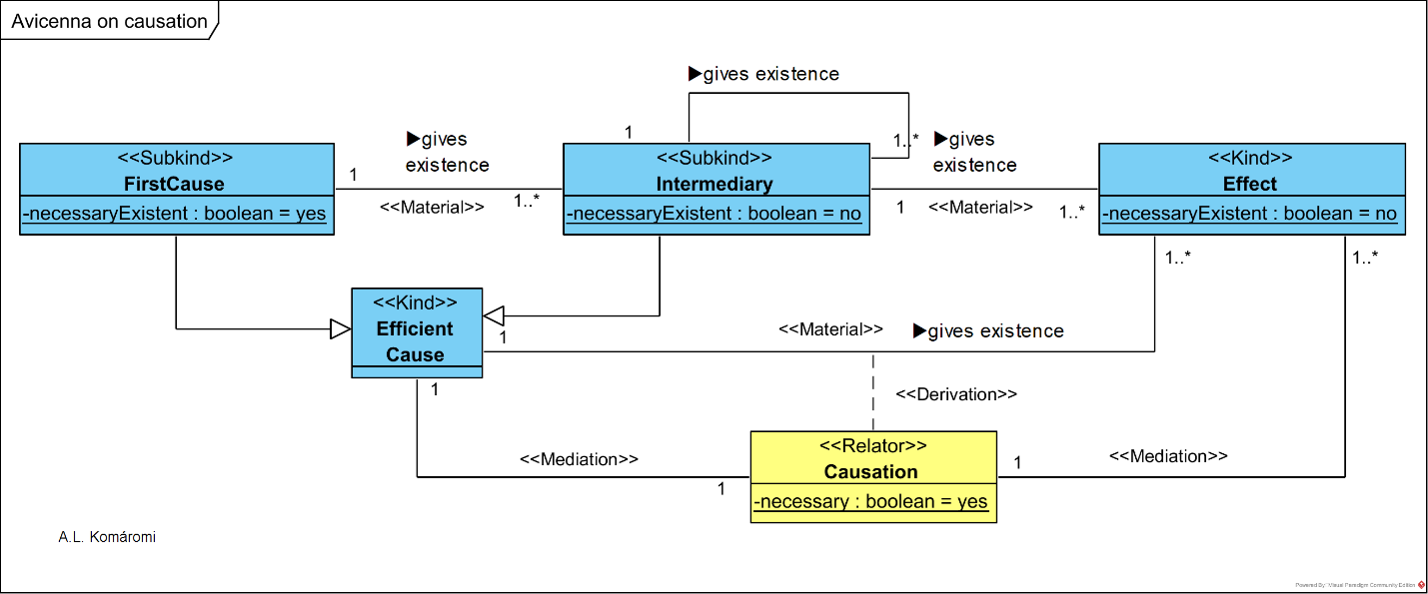

**Figure 7.** Ibn Sina's methaphysical causation chain

**Table 3:** main concepts in Ibn Sina's theory of causation

|  |  |  |
| --- | --- | --- |
| **Class** | **Description** | **Relations** |
| EfficientCause | Ibn Sina "defines the **efficient cause** (illah failiyyah) or agent as that which bestows existence to another (Avicenna MH: 194). He distinguishes his metaphysical definition of the efficient cause from that of the natural philosopher as follows: Metaphysical philosophers do not mean by 'agent' only the principle of motion, as the natural philosophers mean, but the principle and giver of existence, as in the case of God with respect to the world." [6] | gives existence to Effect |
| FirstCause | The **first casue** is a *necessary existent.* "In a series, in fact, the first term—the absolute cause—has the property of being the cause of all that is other than itself." [6] | is subkind of EfficientCause; gives existence to Intermediary |
| Intermediary | The existence of the **intermediary** (al-mutawassiṭ) in contingent, as such is caused by an other intermediary, or by the first cause: "is a cause for one part of the series and an effect for the other, may repeat this relation in a multiplicity if not in an infinity of elements (in an eternal succession of causal relations)" [6] | is subkind of EfficientCause; gives existence to next Intermediary; last Intermediary in chain gives existence to Effect |
| Effect | The existence of the **effect** (al-maʿlūl) is contingent, and is caused: "the effect that is simply caused, finally, has the property of being the cause of nothing." [6] |  |
| Causation | **Causation** relates efficient cause with effect. According to Ibn Sina "everything contingent that is caused to exist is caused necessarily—that is, its existence is necessitated." (5) | relates EfficientCause with Effect |

# ***Ibn Sina's cosmology***

Ibn Sina writes about cosmology and metaphysics in Ilāhiyyāt of Kitāb al-Šifā' (known in English as the Metaphysics of the Book of the Healing or the Book of the Cure). The basis of his theory is a necessary chain of causation starting at the First Principle (as cause), continuing with the chain of Intelligencies and Active Intellect (as effects and intermediaries), and ending with the Sublunary Bodies (as final effects).

His cosmological scheme Neoplatonist, and very similar with al-Farabi's but with some notable differences:

* the Forms of Sublunary Bodies contained and emanated by Active Intellect are undifferentiated universals, not Particulars, as at al-Farabi
* matter is emanated by the Active Intellect (not by the Celestial Sphers as at al-Farabi)
* the existence of the First Cause is necessary by itself, the existence of the chain of Intellects is necessary by the First Cause and contingent by itself (aspects not analyzed by al-Farabi)

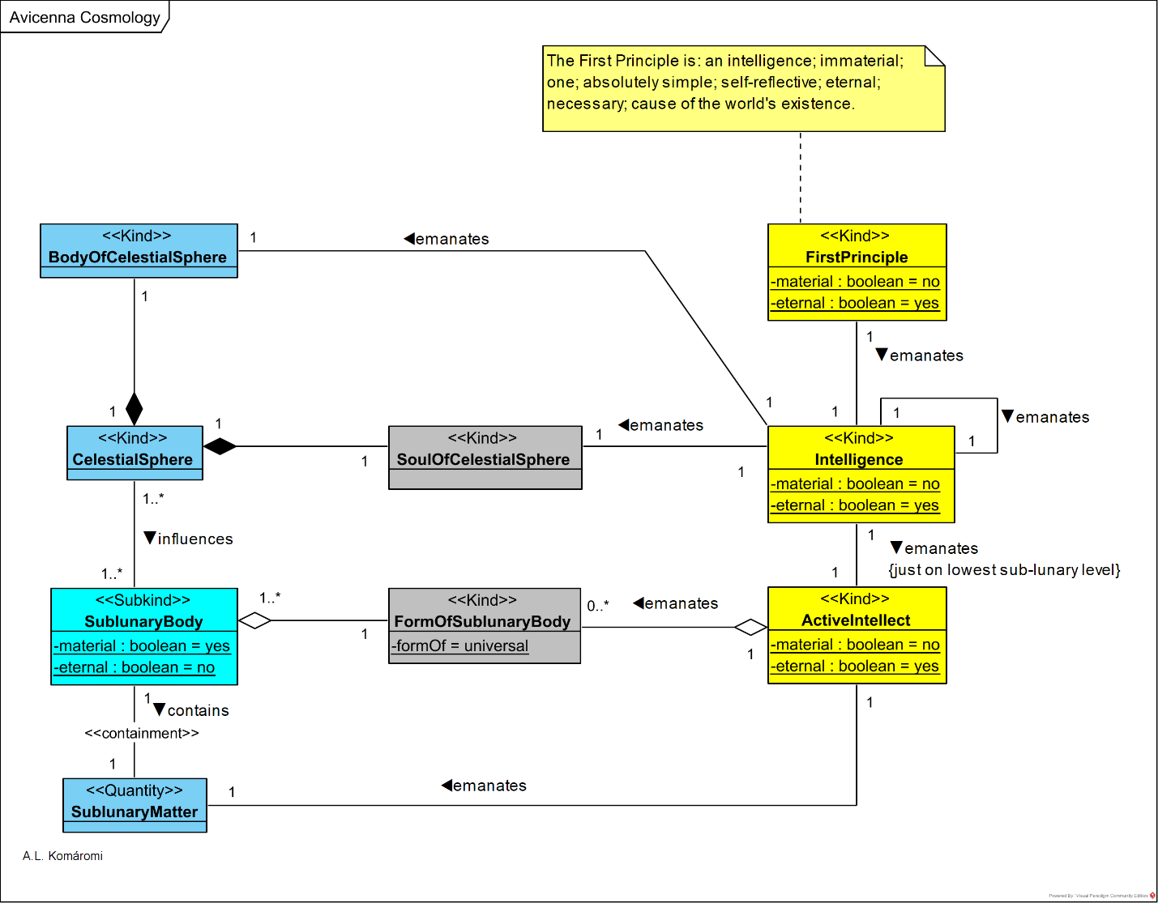

**Figure 8.** Ibn Sina's cosmology

**Table 4:** main concepts in Ibn Sina's methaphysics

|  |  |  |
| --- | --- | --- |
| **Type (Class)** | **Description** | **Relations** |
| FirstPrinciple | The main attributes of the **First Principle** are: intelligence; immaterial; one; absolutely simple; self-reflective; eternal; necessary; cause of the world's existence. "Avicenna considers the world to be 'instaured" or absolutely created (mubdaʿ) and at the same time establishes that it is eternal and eternally in motion, as Aristotle's physics and metaphysics teach. He therefore posits a Principle of the world's existence (wuǧūd)… the final cause is … the same efficient cause that makes things exist (mūǧid). The **First Principle** is therefore a cause in every respect." [3]  The First Principle is also referred as ***Necessary Existent.*** | associated with the (first) Intelligence of the chain |
| Intelligence | A chain of nine **Intelligenc**ies *is necessarily emanated* (fayḍ) from the First Principle, one from the other for the Heavens – the outermost sphere, one for the fixed stars, Saturn, Jupiter, Mars, Sun, Venus, Mercury, and the Moon. Each Intelligence: "- thinks of the First Principle and aims at it, a further intelligence originates; – from the act by which it thinks of itself and aims at itself, two entities originate: a soul, which is an intelligence bound to a body and which is, in some texts, equated to the practical intellect; – and the celestial body to which this intelligence is bound." [3] | emanates: next level of Intelligence; SoulOfCelestialSpere; BodyOfCelestialSpere. Lowest level emanates ActiveIntellect |
| ActiveIntellect | **Active Intellect** (or Agent Intellect) is the last, tenth member of the chain of intelligencies, which emanates *universal (unified, undifferentiated) forms* of Sublunary Bodies, and Matter, which combines into Sublunary Bodies. Since the forms are universal, the differences, particularities of the Sublunary Bodies are caused by the influence of the Celestial Spheres.  Due to the fact, that the members of the chain of intelligencies lose their power with the increasing distance from the First Principle, the Active Intellect is not able to emanate eternal entities, so the sublunary bodies are not eternal, yet in a structure similar to celestial bodies. | emanates FormsOf SublunaryBody; Matter |
| SoulOfCelestial Sphere | **Soul of Celestial Sphere** is emanated by the Intellect when thinks of itself. | part of CelestialSphere |
| BodyOfCelestial Sphere | **Body of Celestia Sphere** is emanated by the Intellect when thinks of itself. | part of CelestialSphere |
| CelestialSphere | **Celestial Sphere** contains Soul of Celestial Sphere and Body of Celestia Sphere. | influences SublunaryBody |
| FormOf SublunaryBody | **Form of Sublunary Body** is a universal (unified, undifferentiated) form emanated by Active intellect. E.g. Form of sea, Soul of man | part of SublunaryBody |
| Matter | **Matter** is emanated by Active Intellect, has the potentiality to be actualized by Form. | contained by SublunaryBody |
| Sublunary Body | **Sublunary Body** is composed of Form and Matter. Its particularity is due to the influence of the Celestial Spheres. |  |

# ***Ontological structure of Ibn Sina's logic***

Ibn Sina was the most crucial logician in the Arabic tradition. He synthesized, re-framed and extended the problems and solutions inherited from Aristotle and the Peripatetic tradition, e.g.:

* enriched Aristotelian *term logic* with the systematical and detailed consideration of modality and reading (see Categorical Propositions),
* introduced *propositional logic* different from the Stoic one (see Hypothetical Propositions).

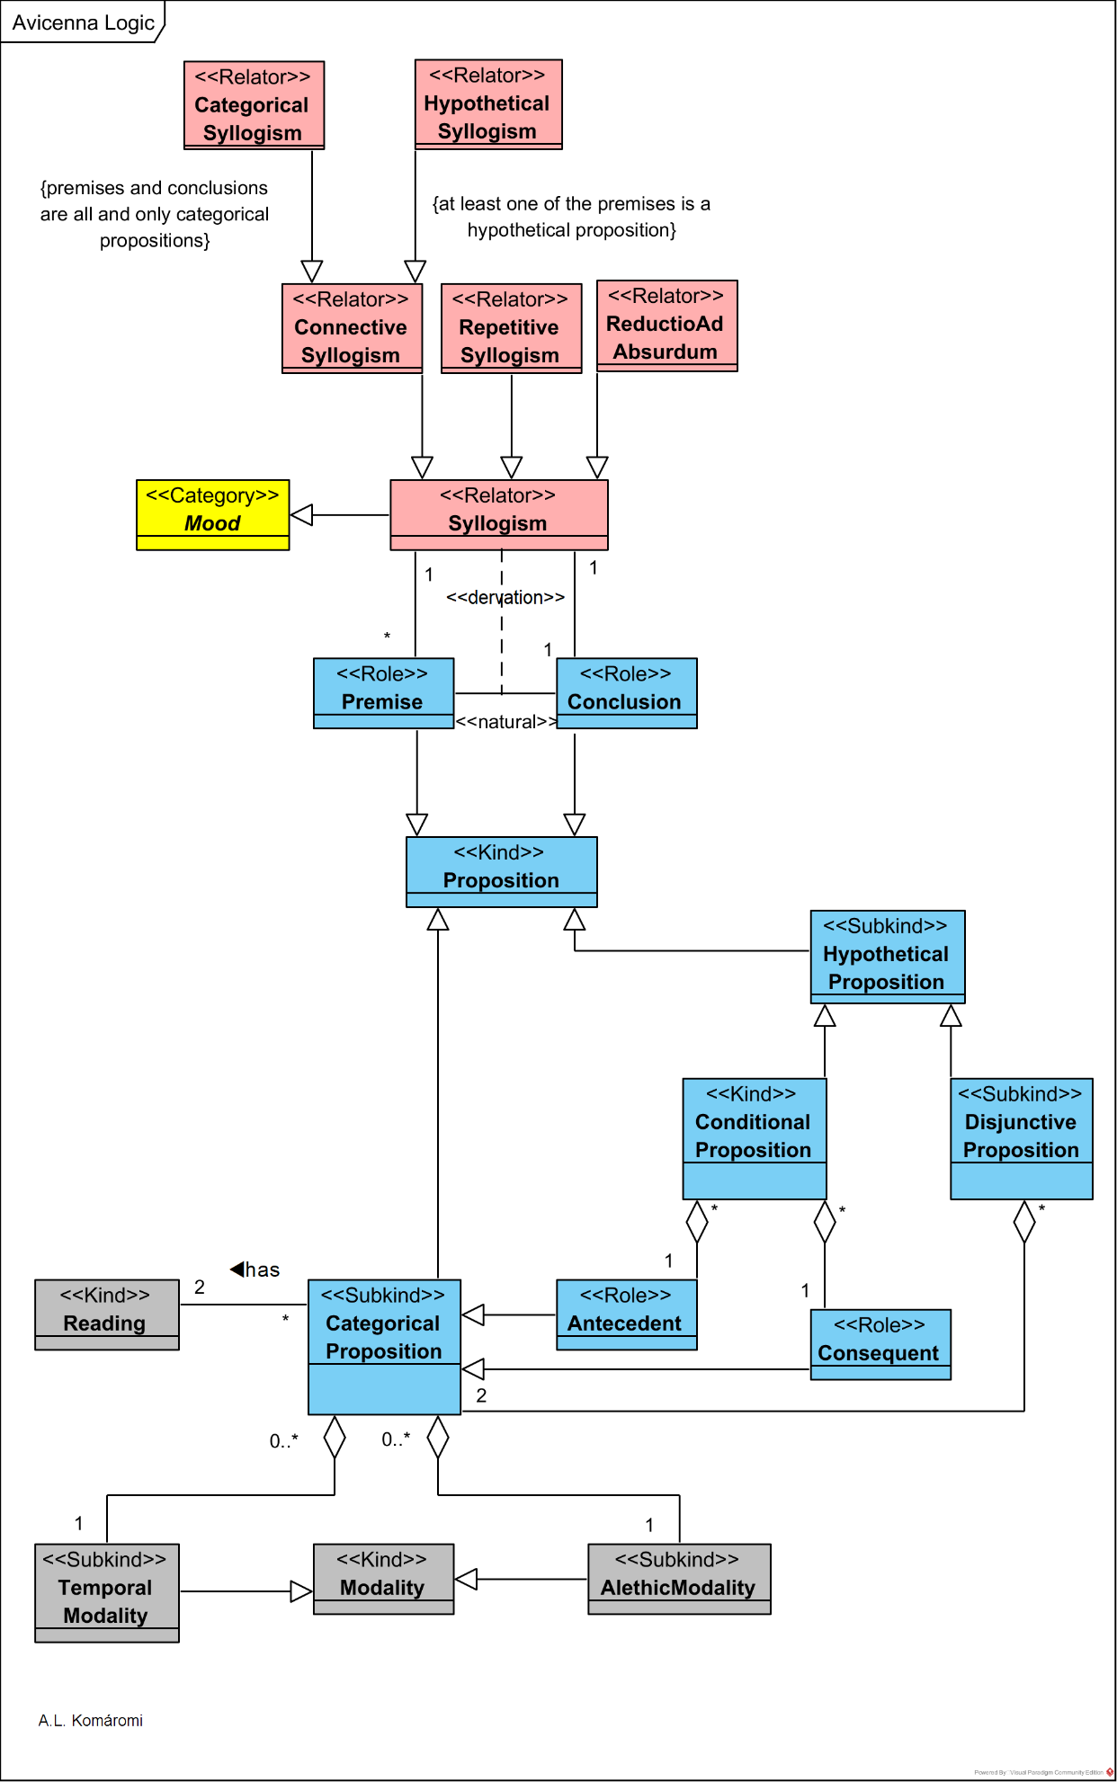

**Figure 9:** Ibn Sina's logic

**Table 5.** Main concepts Ibn SIna’s logic

|  |  |  |
| --- | --- | --- |
| **Type (Class)** | **Description** | **Relations** |
| Proposition | **Proposition** (qaḍiyya) according to Ibn Sina can be (1) categoricals, and (2) hypotheticals. |  |
| Categorical Proposition | "**Categorical** (ḥamliyyāt) **propositions** are subject (mawḍūʿ)-predicate (maḥmūl) propositions expressing a relation (nisba) or judgment (ḥukm) between terms." [7] E.g.: "Avicenna is man." "All man are mortal." | is Proposition |
| Hypothetical Proposition | "**Hypotheticals** (šarṭiyyāt) comprise two main sub-types, depending on whether the component sentences are in connection (ittiṣāl) or in conflict (ʿinād)… The resulting propositional types are conditionals (muttaṣilāt) and disjunctions (munfaṣilāt)…" [7] | is Proposition |
| Conditional Proposition | The **Conditional proposition** is formulating a relation of following (ittibāʿ) between an antwo propositions, an antecedent (muqaddam) and a consequent (tālin), E.g. “***If*** [the sun rises], ***then*** [it is day].” [7] | is Hypothetical Proposition |
| Disjunctive Proposition | The **Disjunctive Proposition** expresses a conflict in terms of a disjunction of propositions (or parts, ağzāʾ). E.g. “***Either*** [this number is even] ***or*** [<this number> is odd].” | is Hypothetical Proposition |
| Antecedent | **Antecedent** is a possible role of a Categorical Proposition in a Conditional Proposition, where designates a condition. E.g. "[the sun rises]" | is shared part of Conditional proposition; is Categorical Proposition |
| Consequent | **Consequent** is a possible role of a Categorical Proposition in a Conditional Proposition, where designates a consequence of the Antecedent. E.g. "[it is day]." | is shared part of Conditional proposition; is Categorical Proposition |
| Modality | **Modality:** "every categorical proposition is modalized, either implicitly or explicitly. The modality may be either temporal […], alethic […], or a combination of both." [7] |  |
| Temporal Modality | **Temporal Modality** can be e.g.: sometime, always, never etc. | is Modality; is shared part of Categorical Proposition |
| Alethic Modality | **Alethic Modality** can be e.g.: necessarily, possibly, impossibly etc. | is Modality; is shared part of Categorical Proposition |
| Reading | "every categorical proposition is subject to an additional **reading**, depending on whether the proposition is taken to express a relation between the predicate and what is picked out by the subject:" (a) referential/substantial (ḏātī): "as long as what is picked out by the subject exists (mā dāma mawğūd aḏ-ḏāt) or (b) descriptional (waṣfī): "as long as it is qualified—or 'described' (mā dāma mawṣūf)—by the subject. This move amounts to adding a temporal parameter that identifies" [7] | is related to Categorical Proposition |
| Syllogism | **Sillogism** is an inference with two ore more ***premises***, and having as ***conclusion*** a proposition. the terms of which are just those two terms not shared by the premises. E.g. P1: “All man are mortal.” P2: “Avicenna is man,” C: “Avicenna is mortal.” | relates 2 or more premises and 1 conclusion; |
| Connective Syllogism | "**Connective syllogisms** are divided into two main types: (1) categorical (ḥamlī) and (2) hypothetical (šarṭī) syllogisms." [7] | is Syllogism |
| Repetitive Syllogism | "The **repetitive** (istiṯnāʾī) **syllogistic** covers inference patterns such as modus ponens and modus tollens (in their conditional and disjunctive variants)… Repetitive syllogisms consist of (i) a hypothetical premise (conditional or disjunctive) containing the conclusion or its negation as one of its parts, and (ii) another premise which asserts or denies (and thereby "repeats") part of the hypothetical premise." [7] | is Syllogism |
| ReductioAd Absurdum | "A **reductio [ad absurdum]** is a compound syllogism (qiyās murakkab)—i.e., a concatenation of syllogisms—consisting of a connective hypothetical syllogism and of a repetitive syllogism. Both categorical and hypothetical propositions may be proved by reductio." [7] | is Syllogism |
| Categorical Syllogism | "**Categorical syllogisms** are those whose premises and conclusions are all and only categorical propositions." | is Connective Syllogism |
| Hypothetical Syllogism | "The **hypothetical syllogistic** investigates arguments in which at least one of the premises is a hypothetical proposition (of type (i), namely one whose parts are themselves categoricals. Purely hypothetical syllogisms are those in which the combination of the premises involve only hypotheticals (conditional-conditional; conditional-disjunction; disjunction-disjunction). Mixed hypothetical syllogisms are those in which the combination of the premises involves a hypothetical (conditional or disjunction) and a categorical." [7] | is Connective Syllogism |
| Mood | **Mood**s are formalized templates of valid (productive) syllogisms | is a generalization of Syllogism |

# ***Ibn Sina on the Prophet as lawgiver***

Ibn Sina writes about political philosophy in the works Healing (Kita¯b al-Shifa¯'), Divisions (Fı¯ Aqsa¯m al-‘Ulu¯m al-‘Aqliyya) and Politics Kita¯b al-Siya¯sa). In these writings:

* He analyzes the subject with a strong emphasis on the role of the *Prophe*t (not directly identified with Muhammad) in the creation of the political community.
* The Prophet, in his view, is a lawgiver, who delivers *divine* and *traditional law* as well to the nation and city.
* The persons living in a city are organized in three hierarchical classes, the Administrators, Artisans, and Guardians.

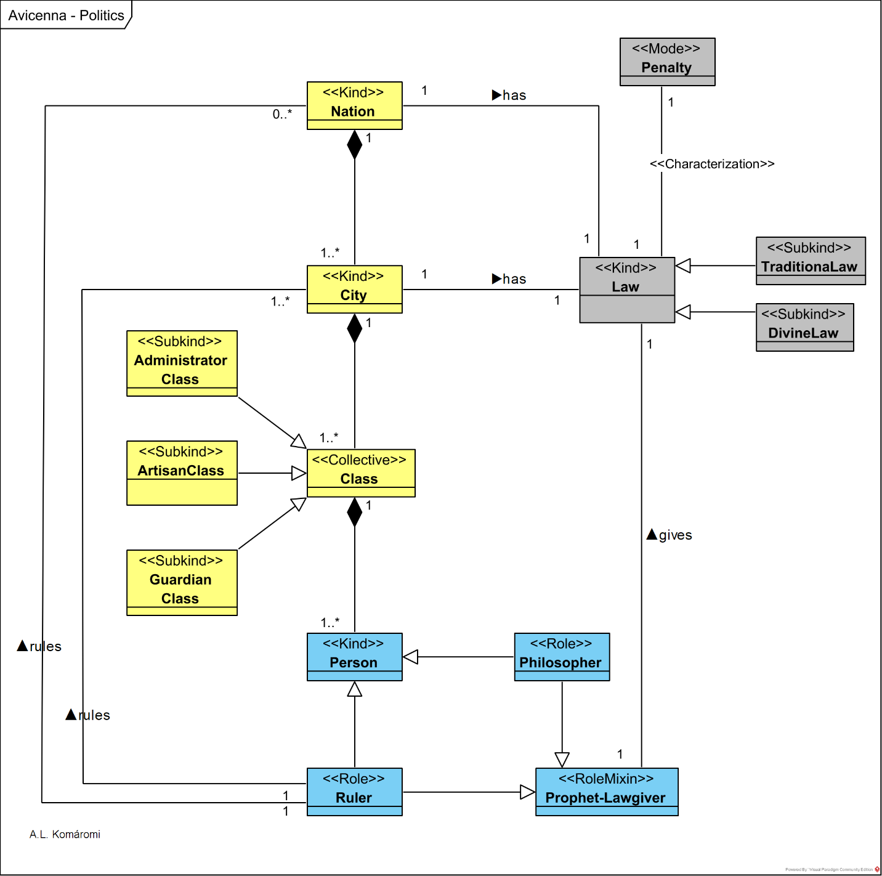

**Figure 10:** Ibn Sina the prophet as a lawgiver

**Table 6:** Main concepts Ibn Sina’s political philosophy

|  |  |  |
| --- | --- | --- |
| **Type (Class)** | **Description** | **Relations** |
| Nation | The prophet, when creates divine law is "no longer concerned with mere cities and communities, his focus is now upon a **nation** (umma) – one of such a size that people may have to migrate or travel long distances in order to reach the spot designated as his abode. Even the time for which he wishes to preserve his laws and teaching has expanded. (Meta, 444:16–445:1). He now thinks it important for the people to remember these things for more than a century or two (Meta, 445:9–10)." [8] For the prophet, the nation is necessary for providing security for the pilgrimage (hajj). | has Law |
| City | "Merely to feed and clothe ourselves, we must enter into exchange relationships with other individuals. To perpetuate such relationships and to give them structure, human beings form **cities** and communities." [8] | is exclusive part of the Nation; has Law |
| Law | "It is then necessary for these larger associations to be regulated and for there to exist a standard on which exchange is based, in other words, for there to be **law** and justice (Meta, 441:3–12). In all of this, says Avicenna, his goal should be to keep matters as simple as possible so that all citizens agree on the principles and do not enter into disputations about beliefs such as would lead them to neglect their civic duties – the fulfillment of those duties being, after all, the whole purpose of his lawgiving (Meta, 442:8–443:9)." [8] |  |
| TraditionalLaw | "The kind of law Avicenna mentions […] as needed to regulate relationships of exchange is **traditional law** (sunna). […] the prophet sets forth a traditional law (sunna) containing precepts about God and the after-life that are needed for a people to come together in communal association." [8] However, this kind of law, established by example, was known in pagan communities also. The Greek philosophers used the term nomos for it. | is subkind of Law |
| DivineLaw | **Divine law** (sharı¯‘a) is revealed by God and helps people to prepare their souls for happiness in the after-life. | is subkind of Law |
| Penalty | "Because fear of punishment in the life to come does not suffice to restrain all people from wrongful deeds, Avicenna notes that the prophetlawgiver must set down punishments, **penalties**, and prohibitions to prevent them from disobeying 'the divine law' (al-sharı¯‘a; see Meta, 454:2–4)" [and traditional law]. [8] | characterizes Law |
| Class | "Avicenna begins his enumeration of the prophetlawgiver's political ordering by noting that his first objective is to provide the city with three **classes** or orders administrators, artisans, and guardians (Meta, 447:4–5). Reminiscent as such an ordering is of Plato's Republic, even though administrators here take the place of Socrates' philosopher-kings, Avicenna does not elaborate on the idea." [8] | Class is exclusive part of the City; is a collection of Persons |
| AdministratorClass, ArtisanClass, GuardianClass | **Administrators, Artisans and Guardians** are three classes of the City. | subkind of Class |
| Person | A human **person**. |  |
| Prophet-Lawgiver | "The best or most virtuous of human beings is the one who has so perfected his soul that he has become fully rational and acquired the practical moral habits permitting him to manage his own affairs in an excellent manner. And among those who reach this level of accomplishment, the **prophet** **[lawgiver]** is the best. Two additional qualities give him this edge of superiority, namely, his ability to hear the speech of God and to see God's angels (Meta, 435:6–16). […] Differently stated, the prophet completes the partial lives of the philosopher and the virtuous ruler. The philosopher has a fully developed intellect, but apparently lacks the practical moral habits whose mastery would allow him to manage his own affairs or those of others that is, to rule others – and while the virtuous ruler surely has the latter, he seems to lack the former. Yet this by no means implies that the previously asserted affinity between philosophy and revealed religion is now rejected: on the grounds stated, philosophers can understand the superiority of prophets just as easily or readily as those who embrace the revelation prophets bring." [8] | is the roles of Philosopher and Ruler; gives Law |
| Ruler | The **ruler** has "practical moral habits whose mastery would allow him to manage his own affairs or those of others". [8] | Role of Person; Rules City and/or Nation |
| Philosopher | "The **philosopher** has a fully developed intellect, but apparently lacks the practical moral habits whose mastery would allow him to manage his own affairs or those of others that is, to rule others" [8] | Role of Person |

# ***Ibn Sina's on the phases of human intellect***

Ibn Sina thinks that the human Intellect goes through a series of four phases – starting from the empty potentiality of a newborn to the fully actualized intellectual faculty containing Forms acquired from the Active Intellect (see also [3.1.3](http://visual-philosophy.blog/2019/08/08/ibn-sinas-cosmology/), [3.2](http://visual-philosophy.blog/2019/08/15/ibn-sina-on-the-soul/)).

The following [OntoUML](https://ontouml.org/) diagram shows the four phases of the Intellect:

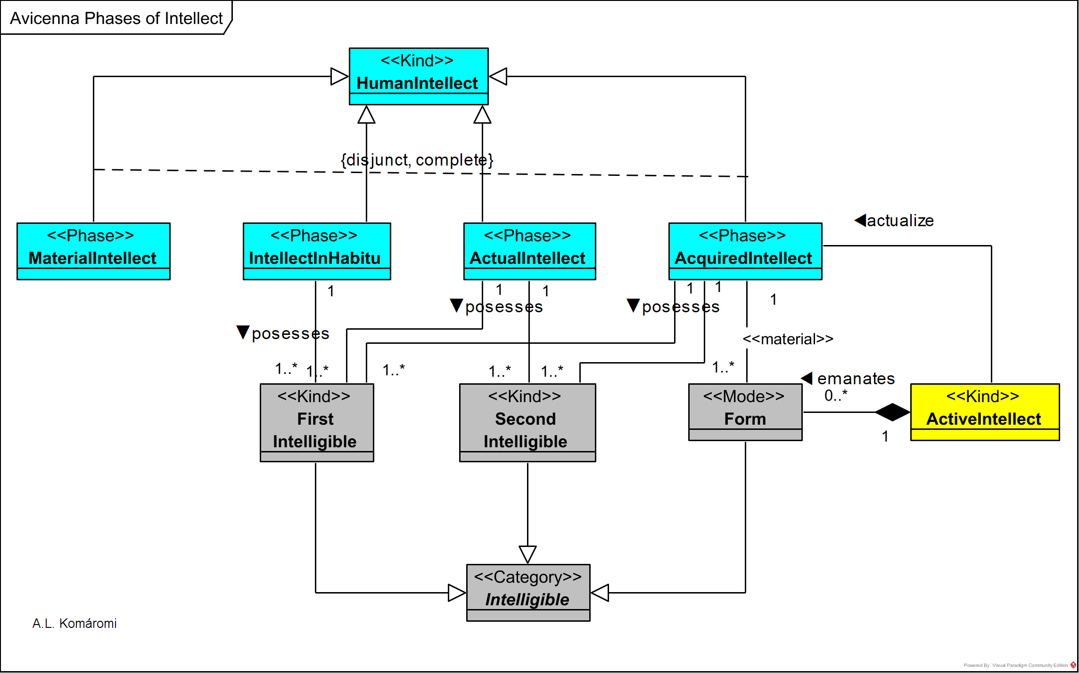

**Figure 10.** Avicenna on phases of intellect

**Table 7.** Main concepts Ibn Sina’s model of the development of intellect

|  |  |  |
| --- | --- | --- |
| **Type (Class)** | **Description** | **Relations** |
| HumanIntellect | **Human intellect** is acquiring concepts/forms through actualization from Active Intellect. |  |
| Material Intellect | **"'Material intellect** 'is the wholly 'unqualified potentiality' for thought which belongs to 'every member of the species.' It is a 'disposition' (isticdad) inhering in the incorporeal human soul from birth."  E.g. "The newborn infant has the potentiality for writing only in the sense that it may eventually learn to write." [9] | phase of Intellect |
| Intellect InHabitu | "'**Intellect in habitu'** (bil-malaka) is the 'possible potentiality' in which the human subject possesses the 'first intelligible thoughts.' These are attained through cogitation. E.g. "Later, the 'boy matures' and comes to 'know the inkwell, the pen, and the letters.' Inasmuch as he controls the rudiments and can go on to master the art with 'no intermediate' step, he is said to have a 'possible potentiality' for writing." [9] | phase of Intellect; posesses FirstInteligible |
| Actual Intellect | **"'Actual intellect,'** despite the name, is a further stage of potentiality— the stage of fully actualized potentiality. It is the 'complete [kamdliyya] potentiality' that is attained when both 'second intelligibles'[derivative scientific propositions] and 'intelligible forms’—that is to say, derivative propositions and concepts—have been added to the 'first intelligibles,' with the proviso that the human subject is not thinking the propositions and concepts. At the stage of actual intellect, the human subject does not 'actually … attend to' his knowledge, yet can do so 'whenever he wishes.'" [9]  These are attained also with the help of cogitation. | phase of Intellect; posesses FirstInteligible and SecondIntelligible |
| Acquired Intellect | "'**acquired** [mustafdd] **intellect**,' which alone is an 'unqualified actuality.' At the level of acquired intellect, 'intelligible forms' are actually 'present' to the man, and he 'actually attends' to them. Avicenna's acquired intellect is, literally, acquired from the active intellect. The unqualified actuality of thought is 'called. . . acquired, because it will be shown . . . that potential intellect passes to actuality' by establishing contact with the active intellect and having 'forms acquired from without imprinted' in man's intellect." E.g. "At a still higher level stands the 'scribe,' who is adept with the [writing] implement,' is 'accomplished in his art,' and can apply the art 'at will.' When he is not exercising his skill, the scribe has a 'perfect' potentiality for writing." [9] | phase of Intellect; posesses FirstInteligible , SecondIntelligible and Form |
| Active Intellect | "The **active intellect** is (1) the emanating cause of the matter of the sublunar world, (2) the emanating cause of natural forms appearing in matter, including the souls of plants, animals, and man, and (3) the cause of the actualization of the human intellect." [9] | actualize Acquired Intellect; emanates Form |
| Form | natural **form** of the lower world | exclusive part of ActiveIntellect; material relation with Intellect |
| FirstIntelligible | **first intelligible**s: "are theoretical propositions of the sort man affirms without being able to 'suppose that they might ever not be affirmed'; examples are the propositions that 'the whole is greater than the part' and 'things equal to the same thing are equal to each other.'" [9] |  |
| SecondIntelligible | **Second intelligibles** are derivative propositions and concepts. |  |
| Intelligible | First intelligibles, second intelligibles and forms are **intelligibles.** |  |

# **Usage of UML use case diagrams: Ibn Sina on the soul**

Ibn Sina (Avicenna) elaborates on the Soul in the book De anima of the Shifā or Healing, according to which:

* **The Soul is immaterial, separated from the body, however, linked to it.**
* **Exterior and interior senses serve the Intellect as a source of knowledge, through a process of abstraction from sense perception.**
* **Knowledge – Forms – is also received from the Active Intellect**

The following [UML](https://www.uml.org/) Use Case diagram presents the main concepts in Avicenna's theory of the human soul, strongly related with his Cosmology (see [[3.3.2]](http://visual-philosophy.blog/2019/08/08/ibn-sinas-cosmology/)), and Aristotle's Psychology (see [[1.3.6]](http://visual-philosophy.blog/2019/01/25/aristotle-on-soul-and-mind/)):

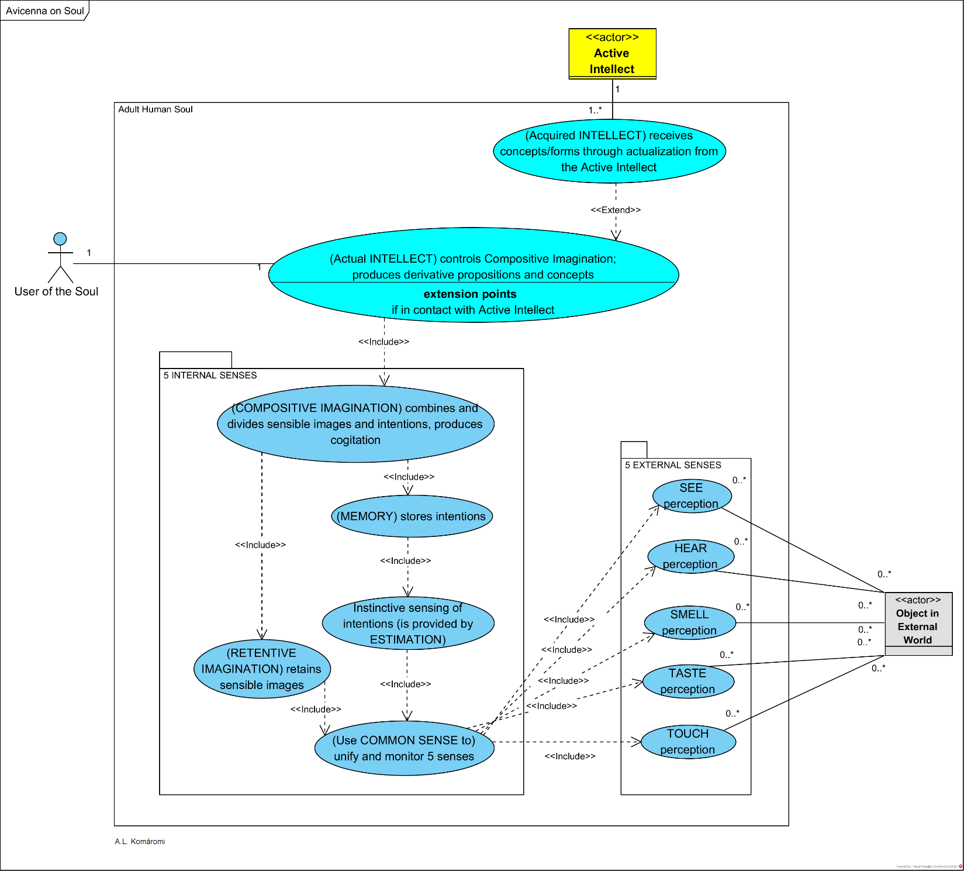

**Figure 11.** Ibn Sina on the soul – presented on UML use case diagram

**Table 8.** How the Soul work according to Ibn Sina

|  |  |  |
| --- | --- | --- |
| **Faculty** | **Related Use Case** | **Relations** |
| EXTERNAL SENSES | Use TASTE, TOUCH, SMELL, HEAR, SEE perception: are shared by non-rational and rational animals. | Communicates with Object in External World |
| COMMON SENSE (receptive) (al-mushtarak) | (Use COMMON SENSE to) unify and monitor 5 senses, present in animals also. | Includes all 5 extenal seneses |
| RETENTIVE IMAGINATION (retentive) (al-khayyāl/ al-mutasawwira) | (RETENTIVE IMAGINATION) retains sensible images provided by the External Senses and Common Sense. | Includes “Use COMMON SENSE to) unify and monitor 5 senses” |
| ESTIMATION (receptive) (wahm) | Instinctive sensing of intentions (is provided by ESTIMATION): "While the range of properties included under the rubric of estimative intentions appears to be quite broad, the most vivid and well-known examples that Avicenna gives are of affective qualities, such as the sheep's grasp of the fact that the wolf is her natural enemy, and her recognition of her offspring as an object of affection." **[10]** Estimation is present in animals also. | Includes “Use COMMON SENSE to) unify and monitor 5 senses” |
| MEMORY (retentive) (ḏikr) | (MEMORY) stores intentions – whether of good or of evil. | Includes “Instinctive sensing of intentions (is provided by ESTIMATION)” |
| COMPOSITIVE IMAGINATION (al-mutakhayyila) | (COMPOSITIVE IMAGINATION) combines and divides sensible images and intentions, produces cogitation: "The compositive imagination is posited to account for the capacity to combine and divide sensible forms and images with estimative intentions without reference to the actual configuration of things in the external world, that is, without any stipulation that the external senses have previously been affected by such combinations. […] So it is necessary for there to be a faculty in us by which we do this, and this is the faculty which is called cogitative (mufakkirah) when the intellect employs it, and imaginative (mutaḫayyilah) when the animal faculty uses it." **[10]** Compositive Imagination is present in animals also, but in humans – when controlled by the Intellect – produces cogitative thought. This, through the generalization of the images and intentions and using syllogisms, prepares the Intellect to receive forms from Agent Intellect through emanation/actualization. | Includes “(MEMORY) stores intentions”; Includes “(RETENTIVE IMAGINATION) retains sensible images” |
| INTELLECT | (Actual INTELLECT) controls Compositive Imagination; produces derivative propositions and concepts" through cogitation. | Includes “(COMPOSITIVE IMAGINATION) combines and divides sensible images and intentions, produces cogitation” |
| INTELLECT | (Acquired INTELLECT) receives concepts/forms through actualization from the Active Intellect: "…all new intelligibles must ultimately be explained with reference to a direct emanation from the Agent Intellect." **[10]** | Extends “(Acquired INTELLECT) receives concepts/forms through actualization from the Active Intellect”  Communicates with Active Intellect |

# **Usage of UML activity diagrams: Ibn Sina on scientific method and demonstration**

In the [UML](https://www.uml.org/what-is-uml.htm) Activity Diagram below, I propose a reconstruction of the scientific "business" process based on Ibn Sina's (Avicenna's) ideas about scientific inquiry elaborated in his works Kitāb al-Burhân, Najâh.  
Here are some highlights of his ideas:

* **Sense perception with the involvement of the 5 external and internal senses (see** [**3.2**](http://visual-philosophy.blog/2019/08/15/ibn-sina-on-the-soul/)**) is the starting point of the scientific process.**
* **Abstraction, Induction and Methodic Experience are the activities to acquire First Principles. Syllogisms (see 3.1.**4**) and actualization of the Intellect with Forms provided by First Intellect (see** [**3.1.6**](http://visual-philosophy.blog/2019/08/15/ibn-sina-on-the-soul/)**,** [**3.1.3**](http://visual-philosophy.blog/2019/08/22/ibn-sina-on-the-phases-of-intellect/)**) both have their roles in these activities.**
* **After First Principles are available, new knowledge can be reached with deduction, using syllogisms (see 3.1.**4**).**

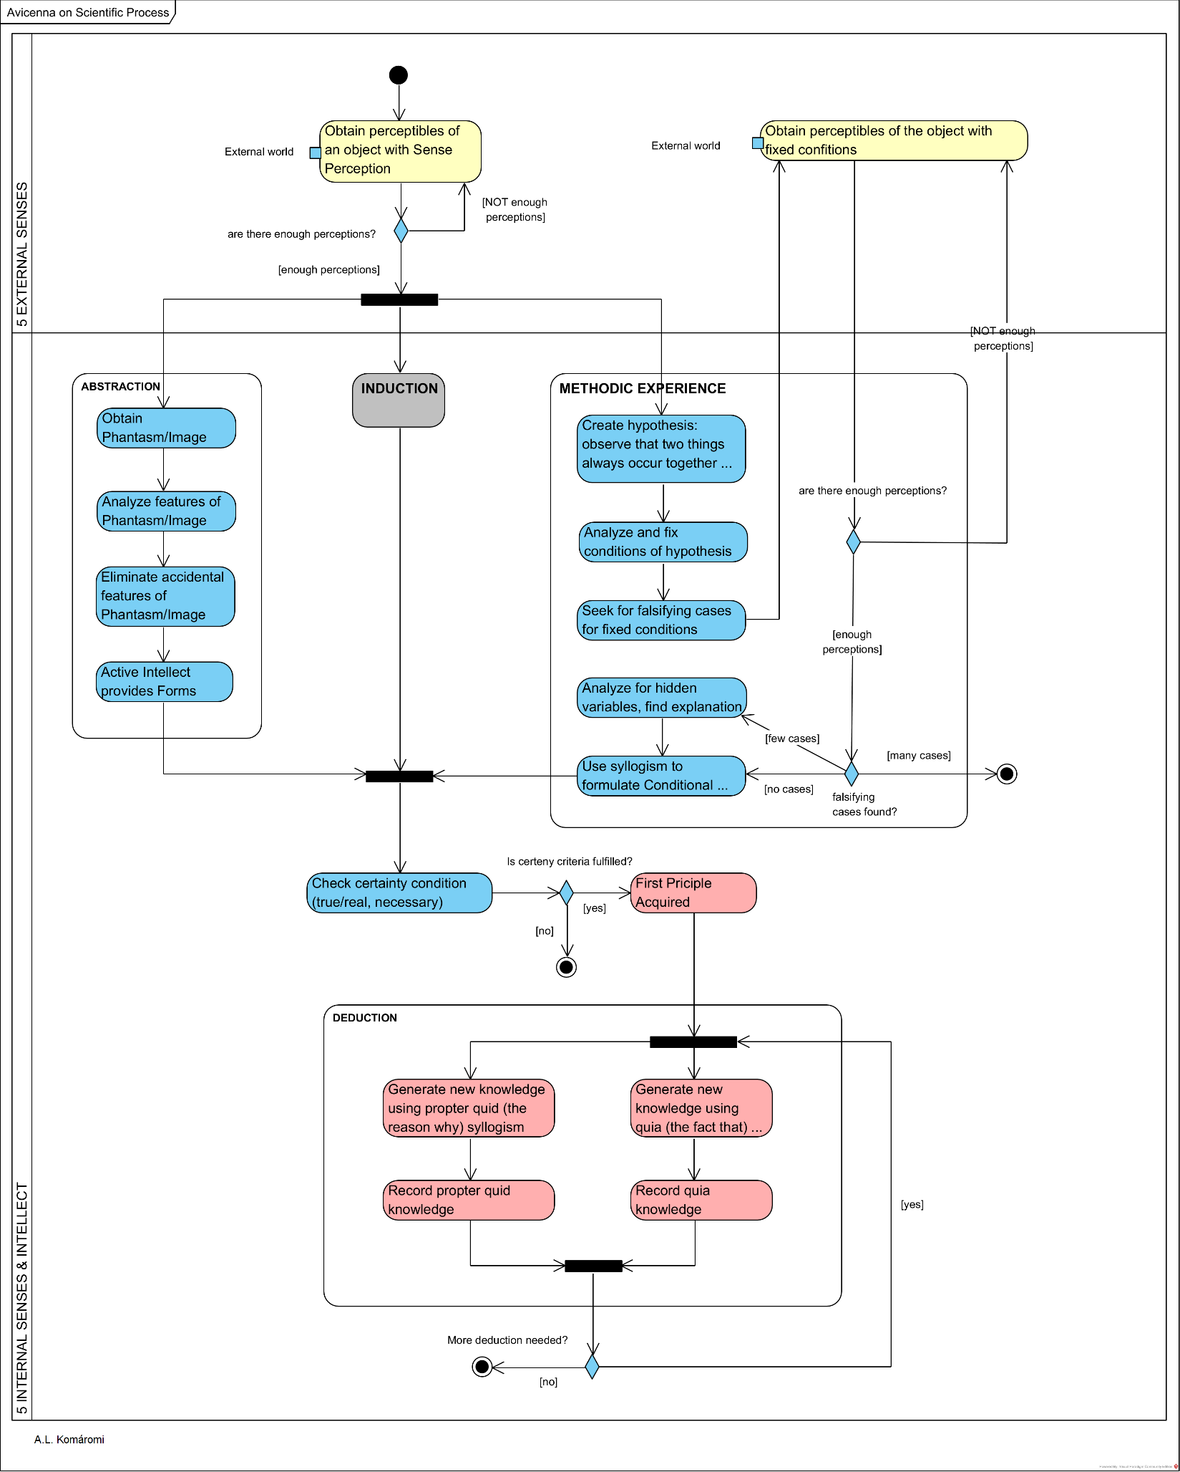

**Figure 12.** Ibn Sina on scientific process presented on UML activity diagram – Induction not detailed for the sake of simplicity

**Table 9.** Ibn Sina on the scientific process

|  |  |
| --- | --- |
| **ACTIVITY/Action** | **Description** |
| Obtain perceptibles of an object with Sense Perception | "the universal premises of demonstration and their principles are obtained only through **sensory perception**…" (McGinnis (2008), cites Avicenna) |
| ABSTRACTION | "by acquiring the **phantasmata** *(ẖyālāt)* of the singular terms through the intermediacy of [sensory perception] in order that the intellectual faculty freely acts on them in such a way that it leads to acquiring the universals as singular terms and combining them into a well-formed statement… [T]he essences perceptible in existence are not in themselves intelligible, but perceptible; however, the intellect makes them so as to be intelligible, because it abstracts their true nature *(ḥqyqthā)* from the concomitants of matter… Thus [the speculative intellect] receives these accidents, but then it extracts them, as if it is **peeling away these accidents** and setting them to one side, until it arrives at the account in which are common and in which there is no variation and so acquires knowledge of them and conceptualizes them. The first thing that [the intellect] inquires into is the confused mixture in the phantasm; for it finds accidental and essential features, and among the accidents those which are necessary and those which are not. It then isolates one account after another of the numerous ones mixed together in the phantasm, following them along to the essence. (McGinnis (2008), cites Avicenna) "this is not Avicenna's whole story concerning abstraction and acquiring first principles; for as he says later, acquisition of the first principles also involves "a conjunction of the intellect with a light emanated upon the soul and nature from the agent that is called the **'Active Intellect'**” [12]. |
| INDUCTION | Avicenna accepts Aristotle’s view on Induction however, criticizes it: “Induction has two elements: one involves the sensible content of induction and the other the rational structure of induction, namely, the syllogism associated with induction. If induction is to provide one with the necessary and certain first principles of a science, then the necessity and certainty of the conclusion of an inductive syllogism must be due either to induction’s sensory element or its rational element or some combination of both. On the one hand, the purported necessity and certainty of induction cannot be known solely through induction’s sensory element; for in good empirical fashion Avicenna recognizes that necessity and certainty are not direct objects of sensation. On the other hand, if the necessity and certainty are due to induction’s rational component, then the syllogism associated with induction should not be question begging. Yet, complains Avicenna, in the scientifically interesting cases one of the premises of an induction will be better known than its conclusion, and so the induction is neither informative nor capable of making clear a first principle of a science.” [12] |
| METHODIC EXPERIENCE | “Ibn Sînâ’s theory of experimentation is by no means modern, it does move one closer to a modern scientific approach; for it emphasizes both the need to set out carefully the conditions under which experimentation or examination have taken place, as well as the tentativeness of scientific discoveries in the face of new observations […] experimentation involves in part seeking falsifying cases…the exceptions [falsifying cases] would be extremely rare, perhaps observed only once or twice. These rare exceptions might indicate that there is not a causal relation, but they might also indicate that the causal circumstances were more complex than initially supposed… Experimentation, with its accompanying syllogism, then, occasions certainty… although experimentation cannot provide “absolute” principles, the natural scientist can use experimentation to discover “conditional,” universal principles, which can function as first principles in a science.” [11]. |
| Check certainty condition (true/ real, necessary) | “Avicenna’s ‘**certainty condition’** (*yqyn)*, […] includes both being true or real *(ālḥq)* and necessary *(ālḍrwry)*” [12]. |
| First Priciple Acquired | If certainty condition is fulfilled. |
| DEDUCTION | “A demonstration according to Avicenna is ‘a syllogism constituting certainty’. In other words, it is a deduction beginning with premises that are certain or necessary that concludes that not only such and such is the case, but that such and such cannot not be the case. Thus, demonstrative knowledge involves possessing a syllogism that makes clear the necessity or inevitableness obtaining between the subject and predicate terms of its conclusion. In addition, Avicenna divides demonstrative knowledge itself into two categories depending upon the type of demonstration employed. Thus there is the demonstration propter quid, or demonstration giving ‘the reason why’ *( brhān lm )* and the demonstration quia, or demonstration giving ‘the fact that’ *(brhān l’n)*.” [12]. |

# **Sources**

**[1] Fabiano B. Ruy, Giancarlo Guizzardi, Ricardo A. Falbo, Cássio C. Reginato, Victor A. Santos, *“From Reference Ontologies to Ontology Patterns and Back”***

**[2] Marek Suchánek, *“OntoUML specification Documentation”,* 2020**

[3] Lizzini, Olga, [“Ibn Sina’s Metaphysics](https://plato.stanford.edu/archives/sum2019/entries/ibn-sina-metaphysics/)“, *The Stanford Encyclopedia of Philosophy* (Summer 2019 Edition), Edward N. Zalta (ed.)

[4] Black, Deborah H., *“Mental Existence in Thomas Aquinas and Avicenna”*

[5] Syamsuddin Arif, “Causality in Islamic Philosophy: The Arguments of Ibn Sina”, *Islam & Science,* Vol. 7 (Summer 2009) No. 1

[6] Richardson, Kara, [“Causation in Arabic and Islamic Thought”](https://plato.stanford.edu/archives/win2015/entries/arabic-islamic-causation), *The Stanford Encyclopedia of Philosophy* (Winter 2015 Edition), Edward N. Zalta (ed.)

[7] Strobino, Riccardo, “Ibn Sina’s Logic”, The Stanford Encyclopedia of Philosophy (Fall 2018 Edition), Edward N. Zalta (ed.)

[8] Butterworth , Charles E., *The Political Teaching of Avicenna,* Topoi-an International Review of Philosophy, 2000

[9] Davidson,Herbert A., *“Alfarabi, Avicenna, and Averroes, on Intellect”*, Oxford University Press 1992

**[10] Black, Deborah H., *“Rational Imagination: Avicenna on the Cogitative Power”*, University of Toronto, Conference presemtation**

[12] McGinnis, Jon, *“Scientific Methodologies in Medieval Islam”*, Journal of the History of Philosophy. 41. 307-327. 10.1353/hph.2003.0033., 2003

[11] McGinnis,  Jon, *“Avicenna’s Naturalized Epistemology and Scientific Method”*, chapter from: The Unity of Science in the Arabic Tradition: Science, Logic, Epistemology and their Interactions, springer, 2008

**Other sources:**

* Raja Bahlul, “Avicenna and the Problem of Universals”, Philosophy & Theology 21
* Davidson, Herbert A., *“Alfarabi, Avicenna, and Averroes, on Intellect”*, Oxford University Press 1992
* Suchánek Marek, OntoUML Specification Documentation, April 01 2020
* M. Cüneyt Kaya, *In the shadow of “prophetic legistlation”; the venture of practical pilosophy after Avicenna*, Arabic Sciences and Philosophy, vol. 24 (2014) pp. 269–296 doi:10.1017/S0957423914000034 © 2014 Cambridge University Press
* **McGinnis, Jon, *“Avicenna’s Naturalized Epistemology and Scientific Method”*, chapter from: The Unity of Science in the Arabic Tradition: Science, Logic, Epistemology and their Interactions, springer, 2008**
* **McGinnis, Jon, *“Scientific Methodologies in Medieval Islam”*, Journal of the History of Philosophy. 41. 307-327. 10.1353/hph.2003.0033., 2003**
* **Gutas, Dimitri,** [**“Ibn Sina [Avicenna]”**](https://plato.stanford.edu/archives/fall2016/entries/ibn-sina/)**, *The Stanford Encyclopedia of Philosophy* (Fall 2016 Edition), Edward N. Zalta (ed.)**
* **Davidson, Herbert A., *“Alfarabi, Avicenna, and Averroes, on Intellect”*, Oxford University Press 1992**
* **Rumbaugh, James, Ivar Jacobson, Grady Booch, *“The Unified Modeling Language Reference Manual (2nd Edition)”*, Addison-Wesley, 2002**
* **OMG® Unified Modeling Language® (OMG UML®) Version 2.5.1, 2017**